Workshop 3 — Student Handout (Login Page)

Task Type: HTML + CSS (Beginner)

Your Work: Complete the remaining 20% of the webpage

You Receive: 80% completed index page and stylesheet

What You Must Complete (Your 20% Work)

A. HTML Tasks
- Add the logo section inside the header and ensure the image contains meaningful alternative text.
- Add accessibility attributes to the navigation bar (for example: navigation role and a descriptive label).
- Ensure all images on the page include clear and meaningful alternate descriptions.
- Mark the Home menu item as the active link.
- Update the Sign In and Sign Up links with correct file paths and proper class names.
- Add the left-side image section beside the login card.
- Add the missing password field in the login form.
- Add the footer elements including footer logo, quick links, support links, and social icons (minimum two links).

B. CSS Tasks
- Style the active link in the navigation bar to visually indicate the current page.
- Style the Sign In and Sign Up menu items as buttons for clear visual emphasis.
- Add styling for a page heading placed above the login card (optional but recommended).
- Style the left-side image area and ensure the image fills the space neatly.
- Apply consistent styling to the password input field to match the username field.
- Style the login button to make it clear and prominent, including a simple hover effect.
- Style the footer layout and organize the footer links clearly.

Minimum Requirements (Checklist)
✓ Navigation bar contains proper accessibility attributes.
✓ Every image includes meaningful alternative text.
✓ Home link is visually marked as active.
✓ Sign In / Sign Up links are corrected and styled.
✓ Password field is added and functional.
✓ Footer includes at least two working links.
Given Output
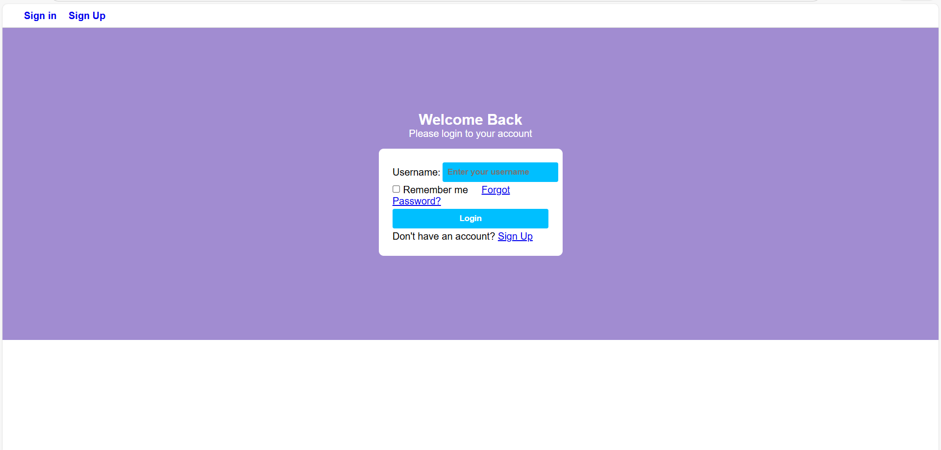
Expected Output
